**PASSPORT MANAGEMENT SYSTEM:**

USE CASE DIAGRAM:

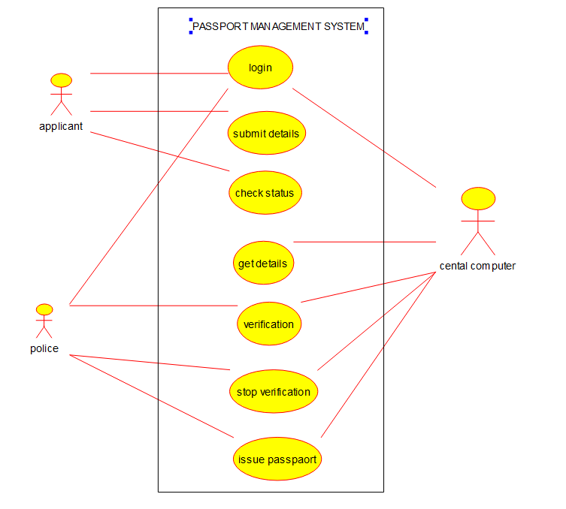

CLASS DIAGRAM:

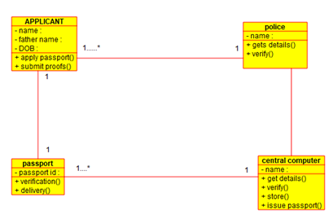

ACTIVITY DIAGRAM:

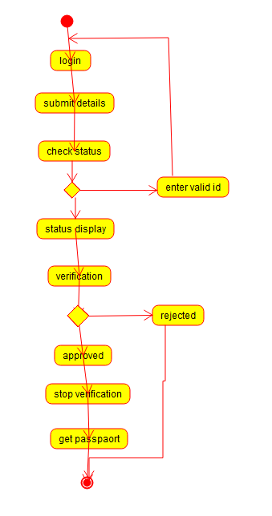

BOOK BANK MANAGEMENNT SYSTEM:

USE CASE DIAGRAMS:

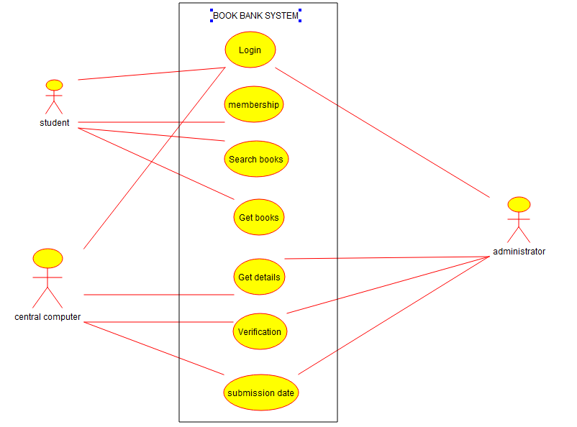

CLASS DIAGRAM:

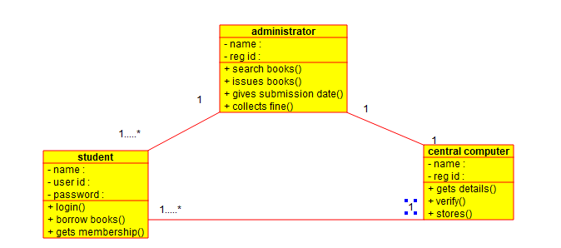

SEQUENCE DIAGRAM:

